Exercise #1

ANGULAR ROUTING

Aitrich Academy.

© All rights reserved.

* **Introduction**

This document is a specification for the exercise problems for the topic, Angular Routing. It tests the student's level of knowledge and understanding of the topic.

This document consists of a set of problems that the student needs to solve and submit to the trainer, in the format specified in the Deliverable section of this document.

This exercise is to be performed only after the theory and workshop sessions of the topic, hence the student would have enough knowledge and confidence on the topic. Ideally, the student should be able to solve the problems himself/herself; however, he/she can seek the assistance of the trainer or lab assistant in case he/she is stuck with a specific problem.

* **Objectives**

The objectives of this exercise are to test the student's understanding and knowledge on the topic, and to allow him to re-iterate his understanding by applying that knowledge in a software problem, so that he can use it in the further Programming endeavors.

**Problem 1:**

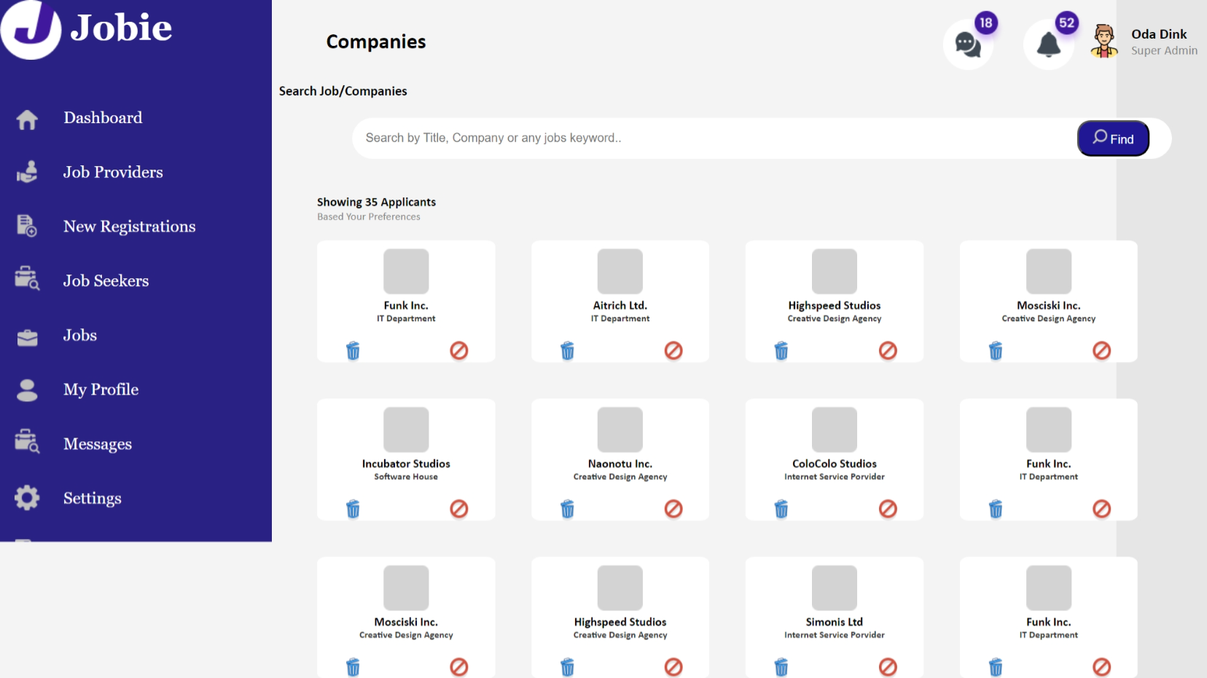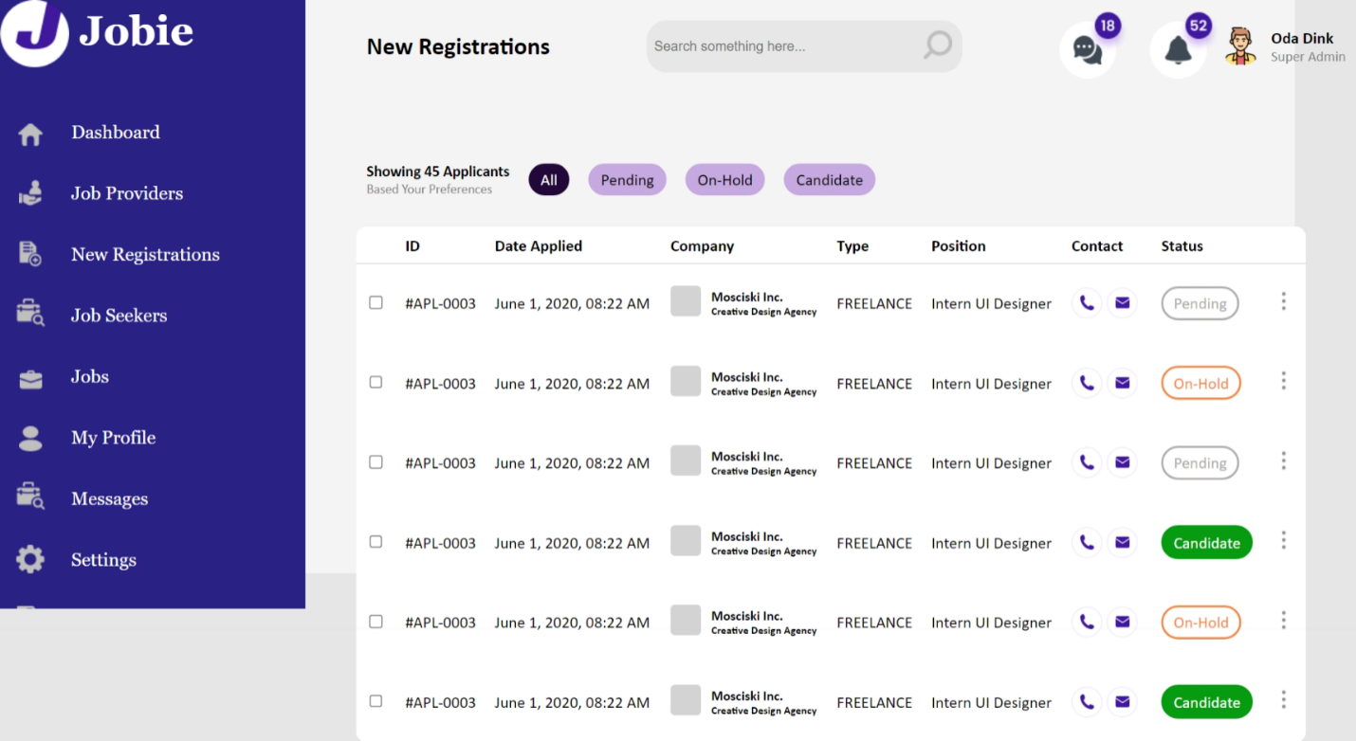

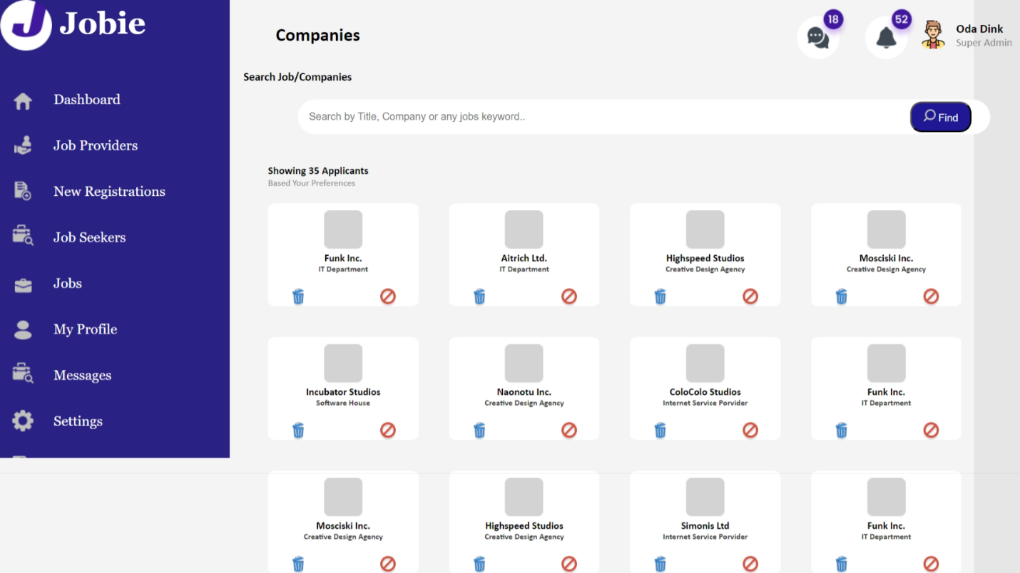

**Features to be developed**

The Angular application comprises several components: a sidebar component, a job Providers component, a registration component, a header component, and a footer component. When a user selects the "Job Providers" link in the sidebar, they are directed to the job Providers component. Within the job Providers component, users have the capability to filter companies based on their preferences. Conversely, if a user clicks on the "Registration" link in the sidebar, they are routed to the registration component. Inside the registration component, users can filter registrations by their status, such as "Pending," "On Hold," and "Candidate," by clicking on the respective buttons.

* **Deliverable**

The entire program should be developed in a single Basic Angular application and delivered as a git hub link.

* **Demo**

The student should demonstrate the program to the instructor on a PC, by explaining the features one by one.

* **Conclusion**

The completion of this exercise should re-iterate the student's confidence on Angular components. Please make sure you have gained enough confidence to move on.